Sample parent-child hierarchy in a table:

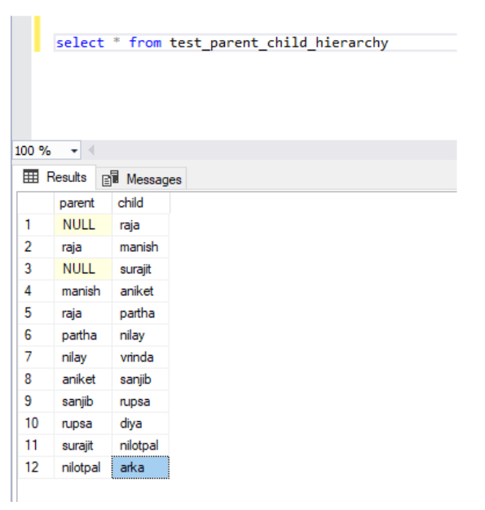

Find the depth/distance of each child and who is the ancestor:

WITH MyCTE

AS

(

— anchor

SELECT child, Parent,1 AS [Level],

CAST(child AS VARCHAR(MAX)) AS Hierarchy

FROM test_parent_child_hierarchy t1

WHERE Parent IS NULL

UNION ALL

–recursive member

SELECT t2.[child], t2.Parent,M.[level] + 1 AS [Level],

CAST((M.Hierarchy + ‘>’ + t2.child) AS VARCHAR(MAX)) AS Hierarchy

FROM test_parent_child_hierarchy AS t2

JOIN MyCTE AS M ON t2.Parent = M.child

)

SELECT *, replace(substring(hierarchy, 1, charindex(‘>’, hierarchy)), ‘>’,”) ancestor FROM MyCTE

